Software Requirements Specification

for

Gogy
Version 1.0 approved
Prepared by Kate Martel, Isabel Laylend, Nico Farago Dumsch, and Claire Kelley
Team Bruen
10/15/25
Table of Contents
1. Introduction 1
1.1 Purpose 1
1.2 Document Conventions 1
1.3 Intended Audience and Reading Suggestions 1
1.4 Product Scope 1
1.5 References 1
2. Overall Description 2
2.1 Product Perspective 2
2.2 Product Functions 2
2.3 User Classes and Characteristics 2
2.4 Operating Environment 2
3. External Interface Requirements 3
3.1 User Interfaces 3
3.2 Hardware Interfaces 4
3.3 Software Interfaces 4
3.4 Communications Interfaces 4
4. System Features 4
4.1 System Feature 1 4
5. Other Nonfunctional Requirements 5
5.1 Performance Requirements 5
5.2 Safety Requirements 5
5.3 Security Requirements 5
5.4 Software Quality Attributes 6
6. Other Requirements 6

Revision History
Name | Date | Reason For Changes | Version
Initial Version | 10-15-25 | Initial | 0.01
Updated Version | 10-26-25 | Feedback from Deliverable 1 | 0.02

Introduction

Purpose

Gogy (version 1.0.0) is an online resource focused on developing AI awareness and education. The premise of the site is to establish an unbiased tool that anyone is able to access to better understand how AI “thinks”, as well as the ethical, legal, and cybersecurity considerations. The site’s users are able to assess their knowledge through quizzes on these topics.

Document Conventions

This document is based on the SRS Document template provided by Karl E. Wiegers (Copyright © 1999, Permission was granted to use, modify, and distribute this document). Formal structure is applied and each section is divided by category, which is then broken into subcategories. All items are to be in Times New Roman size 11 font, single spaced. Italicises are used exclusively for diagram and image captions.

Intended Audience and Reading Suggestions

This document is designed for the developer team, including the designers and project managers. This document will also be made available for users to see the purpose and objective of Gogy, which can be accessed through our Github repository. Chronological reading is highly recommended, and for specific needs, please navigate to the table of contents to easily find the relevant content items. The table of contents can be found on page 2.

Product Scope
Gogy is designed to offer a standard of knowledge for a broad range of backgrounds. Users will gain benefit from the teaching methods, with carefully prepared instructional modules and quizzes, as well as high-quality technical overview on how AI “thinks”. The website is not designed to operate as an LLM, or act as a prompt engineering course. The purpose of this tool is to offer insight on the “how”, “why”, and implications of artificial intelligence on a day-to-day basis. The goal is for all users, regardless of expertise and familiarity with AI, to walk away better informed on the tool in terms of how it works and what the implications of the tool are.

References
Team Bruen Github repository : https://github.com/COS420-F25/Team-B.git
This link (provided on 10-26-2025 by the designer) links to the developer’s Github for project Gogy. Please refer to the repository’s README file for further details on the application, including install and project declarations.

Overall Description

Product Perspective
Gogy is a new, self-contained product. The developers spent time researching if similar options exist out there in terms of AI educational resources, but nothing is centralized and presented in such a way that anyone (regardless of technical background) is able to access and easily understand how AI works and the implications of it. Gogy seeks to bridge this gap, and offer valuable training on AI principles for free as a novel solution for a wide array of users.

Product Functions
The key components of Gogy’s use cases are to:
- Provide high-level insight into how AI “thinks”
  - A user-explorable 3-d model of a deep learning model will be available
  - A guided walk through will be provided for a step-by-step explanation
- Offer insight into the considerations that must be taken when thinking of applying AI
  - From the legal and cybersecurity perspective
  - From an ethical perspective
- Allow users to quiz themselves on their understanding of the aforementioned items
  - Quizzes for each section noted above, as well as correct answers to allow users to interact with the content for better learning.

User Classes and Characteristics
Gogy can be classified into two main user classifications, which more or less have the same functional access to items. The first group is guest users, who do not create an account or log in to use Gogy’s resources. They receive access to all items, but are unable to save their quiz and module progress as they complete sections. The other group consists of users with accounts, who will have their progress stored and linked to their account.

Operating Environment
Gogy exists as a website domain, and is able to operate on any OS that supports browser access to the web. The site is designed to be compatible with any browser, and should not require any other dependencies aside from that and a robust internet connection.

External Interface Requirements

User Interfaces
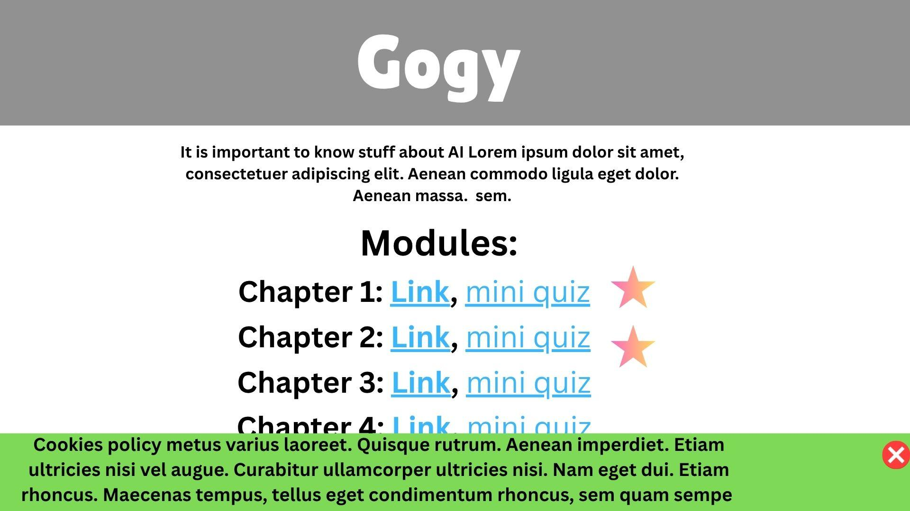
Fig 3.1.1: UI mockup of the homepage. There will be direct links to the assessment quizzes, and a progress tracker to clearly show what has been completed.

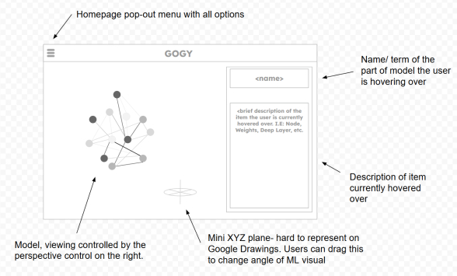
Fig 3.1.2: Image of the ML model visualizer. The model on the left hand side will show a simple neural network that was pre-modelled in Blender, then imported into the HTML site. This will allow users to better spatially visualize the deep learning process. This page is accessed through the homepage pop out, outlined in the upper left.

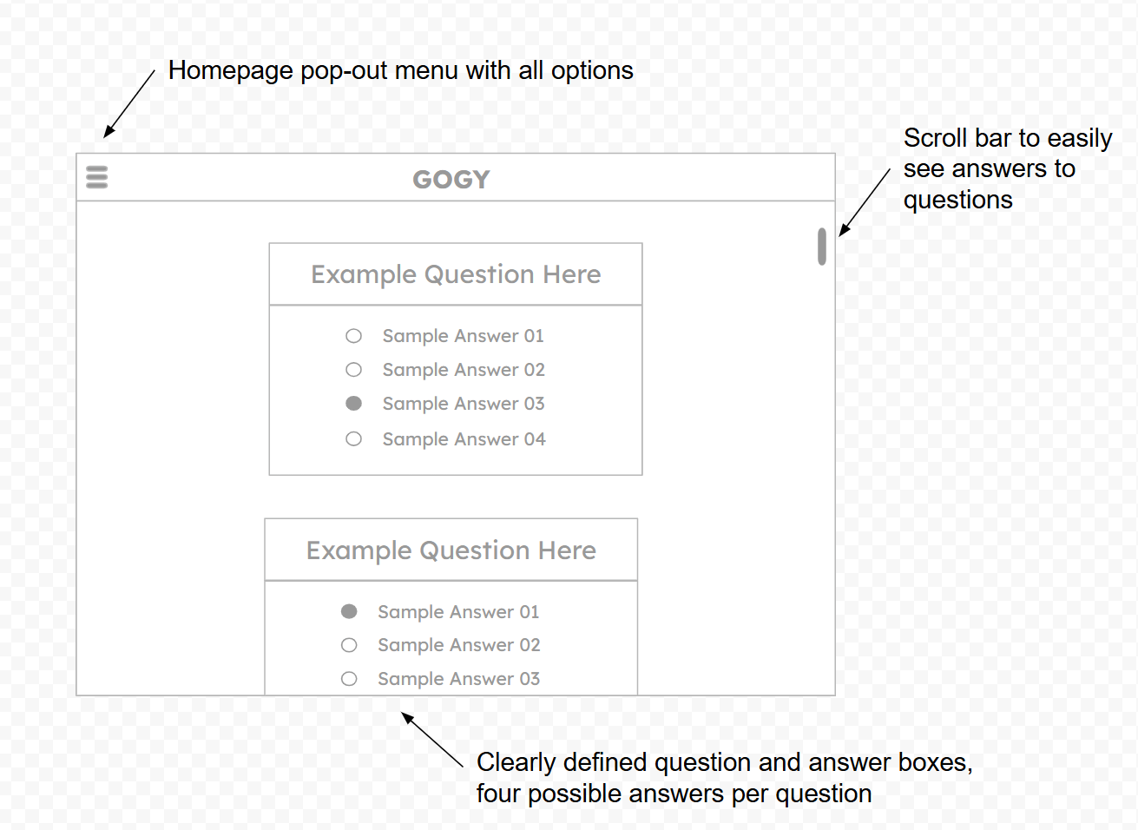
Fig 3.1.3: This UI mockup depicts an example portion of the quoiz feature provided by Gogy to assess knowledge on a module. As you can see here, the quiz feature is relatively intuitive to other multiple choice questions. For each wrong answer selected, the application will provide the right answer, along with a simple message on why the correct answer is the best choice.

System Features
<This template illustrates organizing the functional requirements for the product by system features, the major services provided by the product. You may prefer to organize this section by use case, mode of operation, user class, object class, functional hierarchy, or combinations of these, whatever makes the most logical sense for your product.>

System Feature 1

4.1.1 Functional Requirements
- The Gogy application shall alert a user when they answer a check-for-understanding question wrong.
- The Gogy application shall include at least 3 different learning modules.
- The Gogy application shall have a check-for-understanding quiz at the end of each learning module.
- The Gogy application shall include at least 5 questions in each check-for-understanding quiz.
- The Gogy application shall include a 3D visualization of the processes that happen when you put a query into a large language model.
- The Gogy applications 3D visualization mentioned in requirement 5 shall include at least 5 interactive buttons.
- The Gogy application must give the user an alternative, question specific hint from the prewritten set of hints every time they get a check-for-understanding question wrong, up until they have exhausted the set of prewritten hints.
- The Gogy application shall have at least 5 hints for each check-for-understanding question.
- The Gogy applications check-for-understanding questions cycle of hints shall repeat if the user gets the check-for-understanding question wrong more times than the number of hints.
- The Gogy application homepage shall include a menu of all of the learning modules.
- The Gogy application shall indicate whether the user has completed the check-for-understanding for each module next to the “open module” button for each respective module on the home page.
- The Gogy application shall have a cited source for each claim in each learning module on the bottom of the page that the user is on.
- The Gogy applications set of learning modules shall include at least one learning module with information on what sensitive information should not be submitted to any LLM, with a reputable source cited at the bottom of the page.
- The Gogy application shall have within it no text blocks longer than 280 characters.
- The Gogy application homepage must inform the user of the benefits of AI literacy.
- The Gogy application shall include text that stresses that the LLM is not actually thinking in the traditional sense.
- The Gogy application shall implement caching on the user's browser in order to implement faster loading times.

REQ-1:
REQ-2:

Other Nonfunctional Requirements

Performance Requirements
    - The Gogy application shall assess and give a response to a user's answer to a check for understanding problems within 5 seconds.

Safety Requirements
    - The Gogy application interface shall adhere to WCAG 2.1 accessibility standards.

Security Requirements
    - The Gogy application will inform the users that cookies will be used for the sole purpose of saving user progress without a login.

Software Quality Attributes
  - The system shall have login and registration
  - The system shall be easily usable on mobile android, windows, linux, and apple devices in 2018 and up with the specified OS.
  - The system shall be capable of handling a typical workload of 5,000 users at the same time 95% of the time.

Other Requirements
All requirements can be found above.
Appendix A: Glossary
<Define all the terms necessary to properly interpret the SRS, including acronyms and abbreviations. You may wish to build a separate glossary that spans multiple projects or the entire organization, and just include terms specific to a single project in each SRS.>

